**1. Plugins for VS code:**

1. Markdown Preview Enhanced ([Yiyi Wang](https://marketplace.visualstudio.com/publishers/shd101wyy))

[Documentation click here](https://shd101wyy.github.io/markdown-preview-enhanced/#/)

1. Banner Comments +

[Click here](https://marketplace.visualstudio.com/items?itemName=lunarlimbo.banner-comments-plus)

1. Prettier - Code formatter

[Click here](https://marketplace.visualstudio.com/items?itemName=esbenp.prettier-vscode)

1. Python

[Click here](https://marketplace.visualstudio.com/items?itemName=ms-python.python)

1. REST Client

[Click here](https://marketplace.visualstudio.com/items?itemName=humao.rest-client)

1. Todo Tree

[Click here](https://marketplace.visualstudio.com/items?itemName=Gruntfuggly.todo-tree)

1. FiraCode

[Click here](https://github.com/tonsky/FiraCode)

**2. Standards of writing README.md:**

### **What is it?**

A [README](https://en.wikipedia.org/wiki/README) is a text file that introduces and explains a project. It contains information that is commonly required to understand what the project is about.

### **Why should I make it?**

It's an easy way to answer questions that your audience will likely have regarding how to install and use your project and also how to collaborate with you.

### **How should I make it?**

While READMEs can be written in any text file format, the most common one that is used nowadays is [Markdown](https://en.wikipedia.org/wiki/Markdown). It allows you to add some lightweight formatting. You can learn more about it [here](http://commonmark.org/), which also has a helpful [reference guide](http://commonmark.org/help/) and an [interactive tutorial](http://commonmark.org/help/tutorial/). Some other formats that you might see are [plain text](https://en.wikipedia.org/wiki/Text_file), [reStructuredText](https://en.wikipedia.org/wiki/ReStructuredText) (common in [Python](https://www.python.org/) projects), and [Textile](https://en.wikipedia.org/wiki/Textile_(markup_language)).

You can use any text editor. There are plugins for many editors (e.g. [Atom](https://github.com/atom/markdown-preview), [Emacs](https://github.com/jrblevin/markdown-mode), [Sublime Text](https://github.com/revolunet/sublimetext-markdown-preview), [Vim](https://github.com/suan/vim-instant-markdown), and [Visual Studio Code](https://code.visualstudio.com/docs/languages/markdown#_markdown-preview)) that allow you to preview Markdown while you are editing it.

You can also use a dedicated Markdown editor like [Typora](https://typora.io/) or an online one like [StackEdit](https://stackedit.io/editor) or [Dillinger](http://dillinger.io/). You can even use the editable template below. [Click to know more about README.md](https://www.makeareadme.com/)

**Example:**

**Markdown Input:**

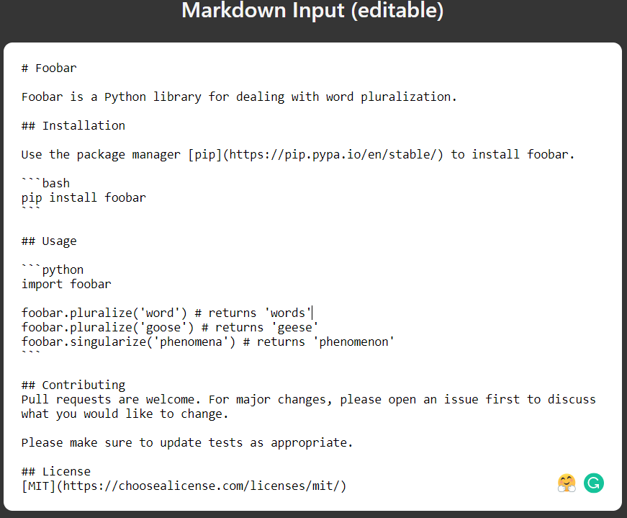

**Rendered:**

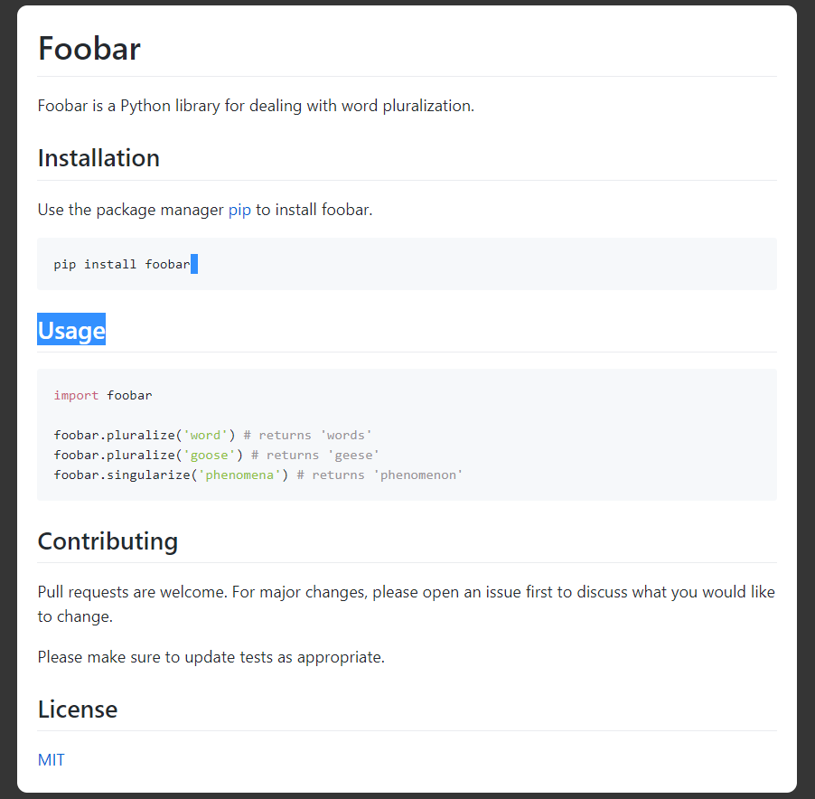

[Click to know more about README.md](https://www.makeareadme.com/)

**3. Flow charts in README.md**

-> For drawing simple SVG flow chart diagrams from textual representation we will be using [flowchart.js](https://flowchart.js.org/)

-> For class diagrams we will be using [mermaid.](https://mermaidjs.github.io/#/classDiagram)

* [click here for github link](https://github.com/mermaid-js/mermaid)
* [Documentation link](http://mermaid-js.github.io/mermaid/#/flowchart)